Tension by Restriction: Designing Strategic Gameplay Through Intentional Constraint in Pet Simulation
Zhiyun Yu
Spring 2026
Introduction
The global virtual pet simulation market is undergoing rapid expansion, with forecasts indicating growth from $326.14 million in 2025 to over $525.05 million by 2030 (Research and Markets, 2025). Despite this strong commercial performance, a systematic analysis of 20 leading mobile pet simulation games reveals a consistent design tendency: approximately 90% of these titles depend on continuous control loops, immediate feedback, and unrestricted visibility to promote relaxation and emotional engagement (Sensor Tower, 2024). Although such approaches effectively support accessibility and user attachment, they also point to a notable design limitation within pet simulation games. In particular, the genre largely lacks systems that incorporate mechanical constraints as a means of introducing cognitive challenge or strategic complexity.
To address this limitation, the present study draws on the Theory of Constraints (TOC), which conceptualizes system behavior as being primarily shaped by its most restrictive element (TOC Institute, n.d.). Within this framework, the principal constraint is defined as monitoring time bandwidth—that is, the limited capacity available to players for observing system states and intervening while managing concurrent tasks in pet simulation gameplay. By introducing spatial limitations alongside temporal bottlenecks, the project examines how deliberately imposed restrictions can reorganize player behavior under conditions of uncertainty.

Research Focus Statement
This study explores how mechanical constraints (e.g., restricted camera views, limited interventions, and delayed action effects) can be intentionally used in simulation games to create psychological tension and promote strategic decision-making. Set in a remote pet monitoring scenario, the game requires players to manage an active, disruptive pet using limited surveillance tools and teleoperated gadgets, and react selectively to prevent harm. Unlike traditional pet simulation games that emphasize relaxation and emotional connection, this project transforms passive observation into an active, tension-driven strategy system. By embedding systemic constraints into core mechanics, the game demonstrates how constraints can focus attention, guide players to play more strategically, and increase engagement without relying on punishment or moral consequences.

Research Gap and Evidence
Despite strong commercial growth, virtual pet simulators rarely use constraint-driven mechanics. This study, conducted by Sensor Tower in 2024, evaluated two design elements which are mechanical constraints (e.g., limited monitoring range, limited interaction, or delayed feedback) and stressful mechanics (e.g., resource scarcity, risk of failure, or strategic ambiguity).
The analysis showed that 18 of the 20 games relied on continuous control loops (e.g., feeding, customization, or care) with continuous visibility and immediate feedback. None of the games implemented systematic constraints, such as limited view angles, intervention caps, or action delays. The remaining two games only used very few restrictive mechanisms. The game Happy Pet Story has intervention cooldown constraints, and some tools require waiting for several minutes before they can be used again. And Talking Ben has a limited number of "punishment" mechanisms, and the number of times it can intervene in bad pet behavior is capped. The former serves time rhythm management and payment guidance, while the latter is to enhance character performance and fun. Neither of them recreates strategic decision-making pressure or cognitive challenges. Overall, they are still relaxing games without strategy.
According to Research and Markets (2025), the global virtual pet simulator app market is expected to grow from $326.14 million in 2025 to $525.05 million in 2030, reflecting high user demand and market saturation. The study mentions that “strategy-oriented simulators emphasize progression mechanisms that reward careful planning,” but does not mention commercial precedents for restriction mechanisms that induce tension and increase the strategic nature of gameplay. This indicates a clear market and design gap: while the genre is booming in terms of revenue and user base, its gameplay remains largely unrestricted. This study fills this gap by intentionally embedding restriction mechanisms into the core design, transforming pet simulation into a field of conscious cognitive challenge and strategic gameplay.

Theoretical Framework-TOC
This research is informed by principles derived from the Theory of Constraints (TOC), which proposes that system behavior is primarily shaped by its main limiting factor. Rather than optimizing all system components equally, TOC emphasizes identifying the primary constraint that governs overall system performance.
In this study, the primary system constraint is monitoring time bandwidth, defined as the amount of time players can spend observing surveillance information. Instead of directly limiting player abilities or action mechanics, the system restricts access to real-time environmental information by requiring players to allocate time to work tasks. As work occupancy increases, available monitoring bandwidth decreases.
This reduction in monitoring time bandwidth increases informational uncertainty. Players must make decisions based on incomplete or delayed knowledge of system states. Within this framework, Work-In-Progress (WIP) is reinterpreted as cognitive and informational workload—the number of system states players must mentally track while away from surveillance. As monitoring interruptions increase, WIP accumulates cognitively rather than physically.
The conceptual model can therefore be expressed as a causal chain:
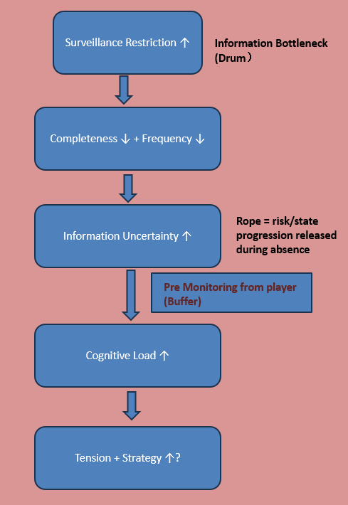
By manipulating monitoring time restriction, the system regulates informational throughput, cognitive pressure, and ultimately strategic adaptation. Surveillance restriction functions not as a deprivation of agency, but as a structural bottleneck that reorganizes player behavior under uncertainty.

Literature Review
- . “A constraint limits the output of every system, whether we acknowledge it or not. When properly identified and managed, constraints provide the fastest route to significant improvement and form the bedrock for continuous growth. When ignored, the constraint may lie idle, squandering system capacity. An out-of-control constraint may also wreck havoc on delivery schedules and cause unpredictable delays.” .
According to the TOC Institute, “a constraint limits the output of every system, whether we acknowledge it or not. When properly identified and managed, constraints provide the fastest route to significant improvement and form the bedrock for continuous growth. When ignored, the constraint may lie idle, squandering system capacity. An out-of-control constraint may also wreak havoc on delivery schedules and cause unpredictable delays” (TOC Institute, n.d.).
This perspective reframes constraints not as weaknesses to be eliminated, but as structural determinants of system performance. Within interactive systems, such as games, this logic suggests that a deliberately designed bottleneck can reorganize player behavior and redirect strategic focus. In this study, surveillance restriction functions as the primary constraint that governs informational throughput. By structuring when and how players access monitoring information, the system reorganizes decision-making behavior under uncertainty.
- Finn Atkinson and Laura Pruszko. 2025. Player Agency Under Constraint: A Pilot Study on the ForcedChoice Effect in Narrative Difficulty Design. In Proceedings of the 2025 Conference on Creativity and Cognition (C&C '25). Association for Computing Machinery, New York, NY, USA, 404–408.
https://doi.org/10.1145/3698061.3735326

This article describes a “forced-choice effect” observed in their study of constrained decisionmaking in Elden Ring, where players, when faced with limited options, tended to focus on dominant strategies. They note that “players converged toward dominant strategies—with variation in how they interpreted them.” In my game, similar constraints—such as limited camera access and intervention chances—push players to prioritize actions and develop adaptive strategies under pressure. This supports the idea that intentional mechanical limitation can sharpen decisionmaking and increase psychological engagement, even when freedom is reduced.
- Spiliopoulos, L., Ortmann, A., & Zhang, L. (2018). Complexity, attention, and choice in games under time constraints: A process analysis. Journal of Experimental Psychology: Learning, Memory, and Cognition, 44(10), 1609–1640. https://doi.org/10.1037/xlm0000535

This article shows that when players face time pressure, they tend to focus attention, simplify decision-making, and rely on quicker strategies without reducing performance. In my game, players are not under strict time pressure but instead face limited spatial and tool-based agency. The fixed number of cameras and restricted use of intervention tools (like toys or distractions) means players must selectively attend to the most relevant cues and prioritize their actions carefully. This aligns with Spiliopoulos et al.'s observation that constraint reshapes player cognition, encouraging deliberate, strategic action and heightened engagement even when temporal urgency is absent.

Historical-Technical Survey
- Five Nights at Freddy’s (Scott Cawthon, 2014)
This game relies on static surveillance cameras, limited energy, and delayed feedback on actions to generate stress and fear. Players must balance limited resources with fragmented visual information to survive the nighttime threats. Its effectiveness comes from forcing players to make decisions with incomplete data and time-sensitive constraints.
My game borrows from its surveillance interface and constraint mechanisms, such as limited visibility and limited intervention, but removes terror and punishment as incentive structures, applying these same systems to a care setting, transforming fear into focused engagement. The game retains the strategic tension of FNAF, but replaces fear with cognitive urgency, making it suitable for non-violent simulation while maintaining emotional intensity.
- Talking Ben (Outfit7, 2011)
Talking Ben is part of the Talking Tom series and is primarily designed as a casual entertainment app. While most interactions are open-ended and humorous, the game introduces a limited use "scold" feature that allows the player to briefly interrupt Ben's behavior a few times a day. This mechanic implies the scarcity of intervention but is designed to build in comedic timing rather than challenge the player's decision-making.
My game learns from this idea of limiting player interaction, but recontextualizes it as a strategic decision-making system rather than a novelty. The limiting mechanic that builds emotional feedback is replaced by a delayed, meaningful intervention system that pushes the player to think strategically, making each action cognitively meaningful rather than pure entertainment.

- Tamagotchi (Bandai, 1996)
Tamagotchi pioneered virtual pet care by providing a minimalist interface with only a few options to choose from. Despite its simplicity, the system creates a deep emotional attachment through lasting consequences - if the user ignores their pet, it may become sick or die. This is one of the first digital examples of limited control generating a large psychological investment.
My project takes this principle of “consequences for inaction” and expands on it by placing the player in the role of a surveillance agent with incomplete information, increasing tension through visual constraints and time delays.

Artifact Pre-Production
This thesis explores how constrained mechanical systems (e.g., limited monitoring, delayed actions, and limited interventions) can create psychological tension and cognitive engagement in a remote pet monitoring simulation. Built for PC using Unreal Engine 5, this prototype improves the playability and strategy of the casual pet simulation genre through a strategic decision-making perspective based on partial information.
The game puts players in the role of a pet owner who is away from home for work, monitoring their pets through a network of fixed cameras accessed through a smartphone interface. Gameplay revolves around switching camera views, detecting destructive behavior (e.g., knocking over objects, chewing furniture), and responding with limited interventions (e.g., voice commands or virtual toys). Interventions are controlled by cooldowns and delays, forcing the player to think carefully and prioritize.
A pet status interface is displayed before the monitoring phase begins. The interface displays key indicators of the pet, such as mood, hunger, and destructive drive. These values are updated over time and affect the likelihood of the pet to engage in destructive behavior. The player must interpret these indicators and determine in advance when to intervene or even switch cameras. This mechanism adds a layer of prediction and resource management to the system, encouraging the player to combine real-time monitoring with strategic foresight.
Unlike traditional pet simulators, this system intentionally deprives players of full autonomy. The goal is not constant interaction, but strategic inaction and anticipation. In "Thesis I", the pet's behavior is driven by a random script, but in Thesis II this could be extended to a finite state machine or lightweight AI. The emphasis is on the player's ability to manage uncertainty and allocate limited attention, especially in the late stages of introducing background distractions - the situation of going to work.

Design methods
Content analysis: A systematic review of 20 commercially successful mobile pet simulators（Table1,2025） observed and studied industry trends towards unrestricted interaction and immediate feedback. These findings highlighted a gap in the research of constraint-based systems in the genre and guided our decision to pursue a set of mechanisms to improve cognitive levels. Theory-driven framework: The design draws on the MDA framework to
Game Title | Platform | Main Mechanics | Constraint Mechanics Present? | Notable Emotional Engagement
My Talking Tom | Mobile | Care, Feed, Dress Up | No | High - Pet animations & feedback
Pou | Mobile | Feed, Clean, Mini-Games | No | Moderate
Bubbu | Mobile | Pet Care, Decorate | No | Moderate
My Talking Angela | Mobile | Care, Fashion, Makeup | No | High - Expressive style
Happy Pet Story | Mobile | Pet Simulation, Decor | Yes (Cooldowns) | High- Whimsical tone
Pet Idle | Mobile | Care, Leveling, Build Rooms | Yes (Resource Wait) | Moderate- Routine Loop
Cat Condo | Mobile | Idle Merge, Collection | Yes (Merge Limits) | Low -Idle Design
Dog Town | Mobile | Care, Breed, Upgrade | Yes (Time for Training) | Low
Hamster Life | Mobile | Feed, Clean, Watch | No | Moderate- Pet Sounds
Pet Shop Story | Mobile | Decorate, Breed | Yes (Room Unlock Timers) | Moderate
Moy | Mobile | Simple Care Loop | No | Low
Talking Ben | Mobile | Talk, Interact | Yes (Limited Voice Use) | High- Voice response
Pet World | Mobile | Animal Care, Rescue | Yes (Care Slots) | Moderate
Pakka Pets | Mobile | Care, Grow Creatures | No | Moderate
Clawbert | Mobile | Collect Claw Toys | Yes (Random Reward System) | Low- Gacha Tone
Cat Room | Mobile | Decorate, Feed | No | Moderate
Pet Hotel | Mobile | Manage Hotel for Pets | Yes (Room Full) | Moderate
My Virtual Pet | Mobile | Mini-Games, Basic Care | No | Low
Pet Rescue Saga | Mobile | Puzzle + Rescue | Yes (Move Limits) | Low
Pet City | Facebook | Build, Visit Friends | Yes (Energy System) | Moderate
structure how mechanical constraints (e.g., fixed viewpoint and input delay) create dynamic changes in priority, tension, and focus. The theory supports the core hypothesis that constraints rather than freedom enhance psychological immersion.
Table1：A systematic analysis of 20 commercially successful mobile pet simulators
Design specifications: The HUD adopts a retro anime and candy color style (similar to muse dash). And it will include:
- A fixed-room monitoring layout (w rooms) with a single active camera feed at a time
- A scripted pet behavior timeline, randomly selecting events from a limited pool (e.g., knock over, chew object)
- A limited-use intervention system (e.g., “throw toy,” “activate sound”), with cooldowns and delayed effect
- A UI overlay that includes both surveillance controls and passive background tasks (e.g., event planning pop-ups)
These specifications help translate abstract design theories into executable gameplay elements suitable for testing.

Worldbuilding and Narrative Primer has a short opening comic sets the scene: the player is about to leave for work, connect to a surveillance system, and must balance daily and realtime pet care. This opening comic not only outlines the player's emotional path but also reinforces the theme of "limited control."

Optional Research: We plan to conduct informal player interviews and digital surveys to collect player feedback on game tension, interface clarity, and emotional reactions to missing interventions.

Design Artifact:
Phase I (Paper I):
Phase I (Paper I): Build and test a minimum viable prototype, focusing on the core loop:
- Three-chamber monitoring system
- Two pet behavior types (scripted)
- Three intervention methods, with cooldowns and delays
- Visual feedback by flashing the screen or shaking an object
- Basic interruption task
- UI (optional toggle) Pet status UI panel showing real-time values (emotion, hunger, destructive drive)

Phase II (post-MVP/Thesis II):
Extend pet behavior logic using AI or behavior trees
Introducing dynamic task interruptions (e.g., emergency calls, scheduling requests)
Add a scoring or feedback system to reflect player success/failure rates
Develop a performance summary screen ("end of day" report)

Pre-Producti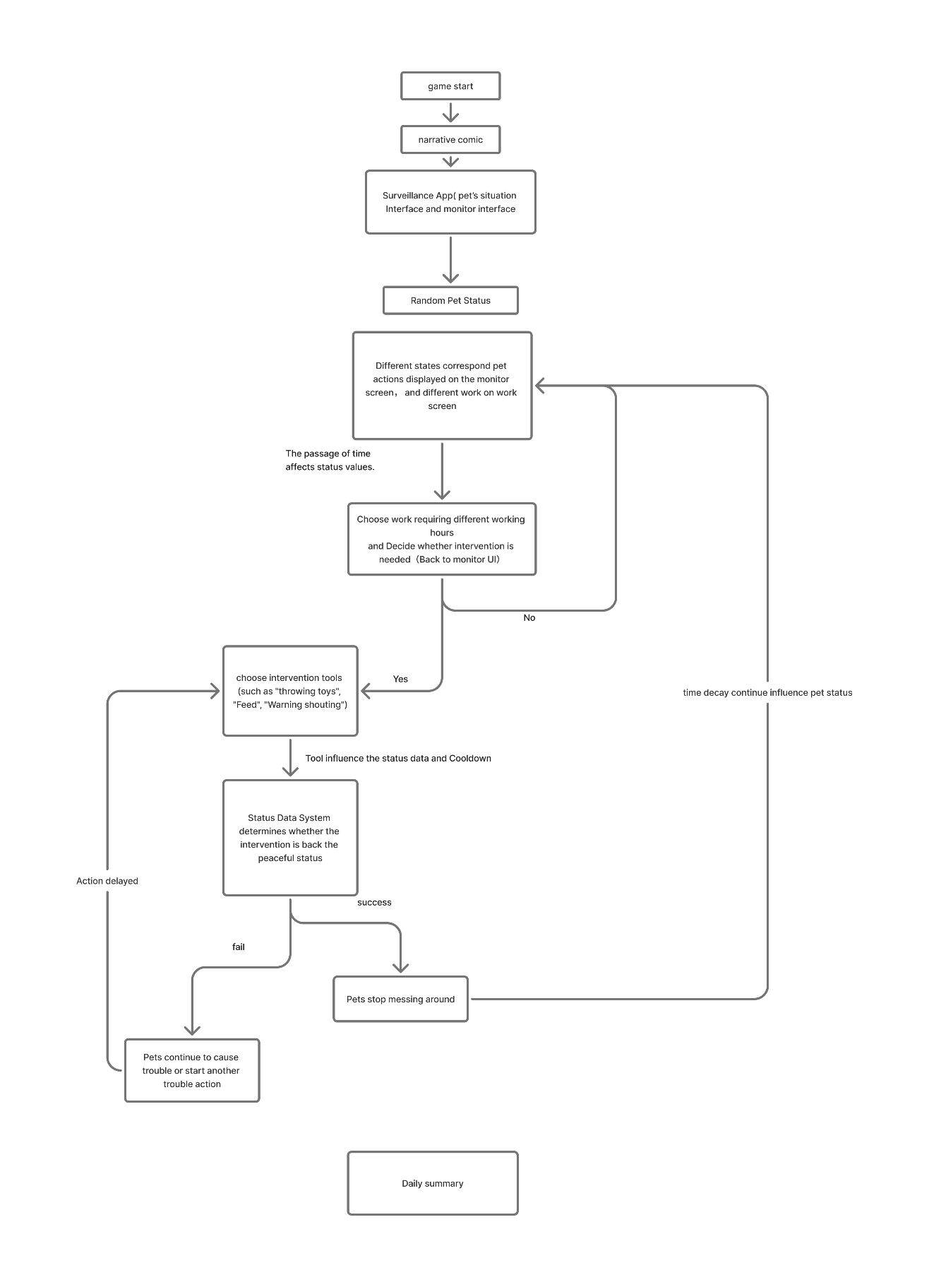

Figure2: Core Loop

UI framework:

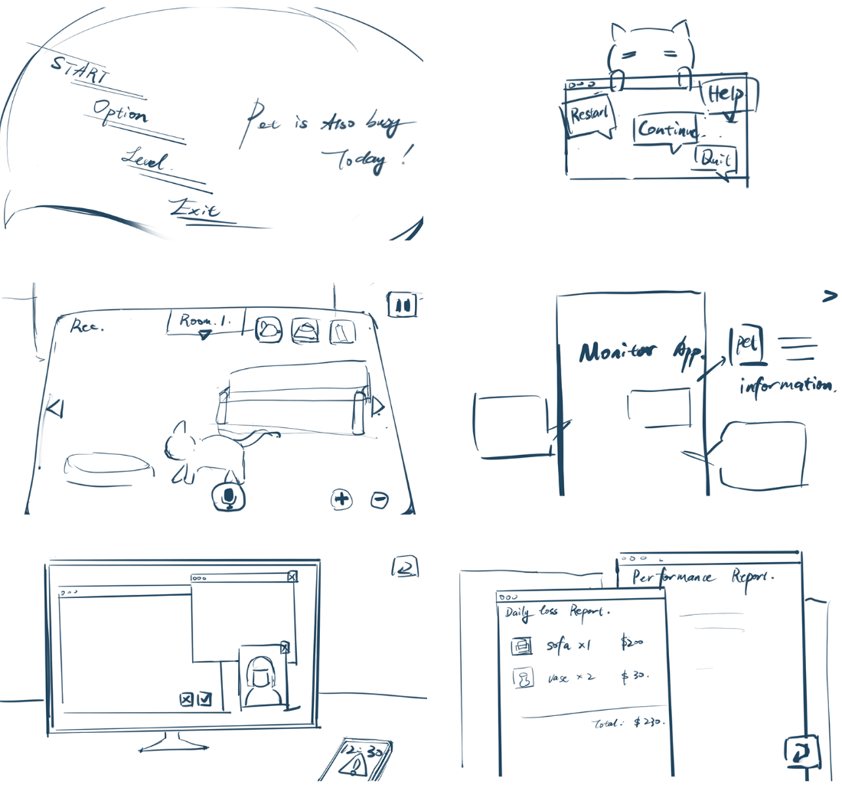
Figure 3: UI Sketch
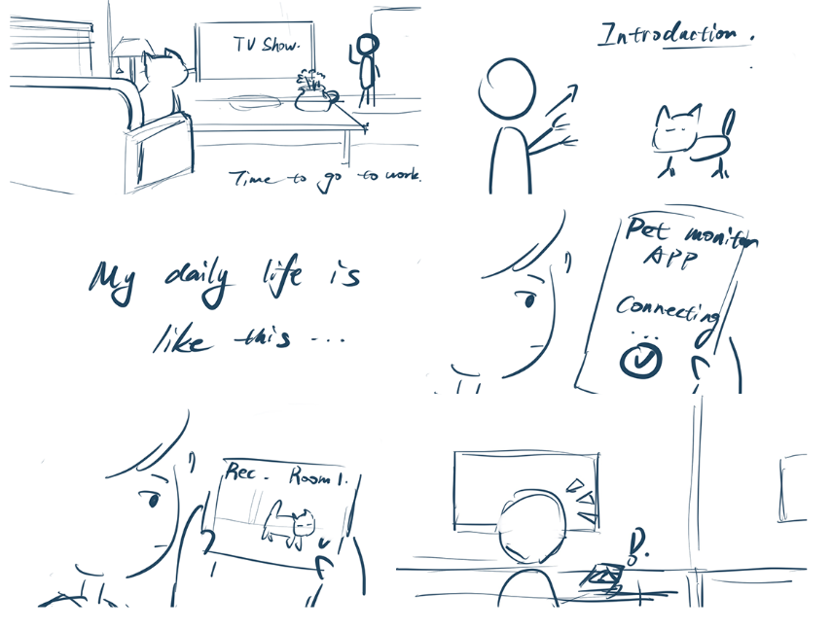
Figure4: Narrative Comic Storyboard (Introduce the background)

Visualization:
Simple sketch collage(figure11,2025) of general visual and color style, which will be dominated by candy colors because the overall game theme's emotional tone is playful to show the cute emotional connection between pets and people.

Figure5: Visual style confirms

Development
Prototype Overview
The main goal of the prototype is system testing. Built using Unreal Engine, the prototype is designed to evaluate the core UI system and the functional relationship between pet behavior states and player actions. Specifically, it explores how players respond to the dynamic changes of three interrelated pet status values: happiness, hunger, and destructiveness. Players are given three behavioral intervention tools - feeding, throwing toys, and shouting - and need to choose the most appropriate action based on the pet's current state.
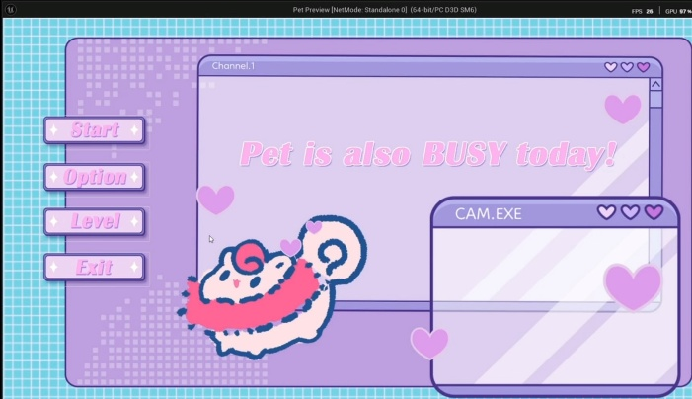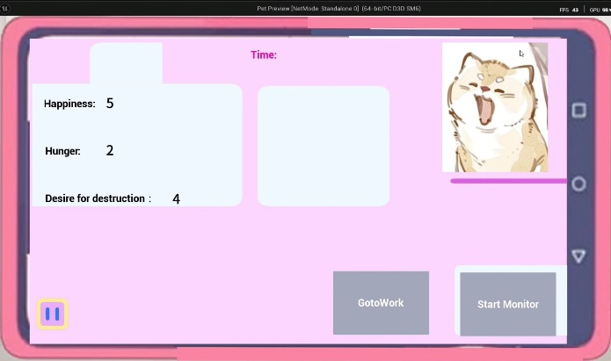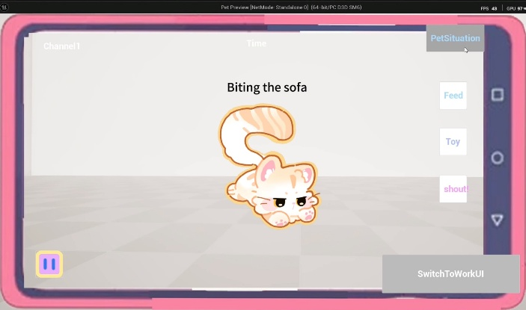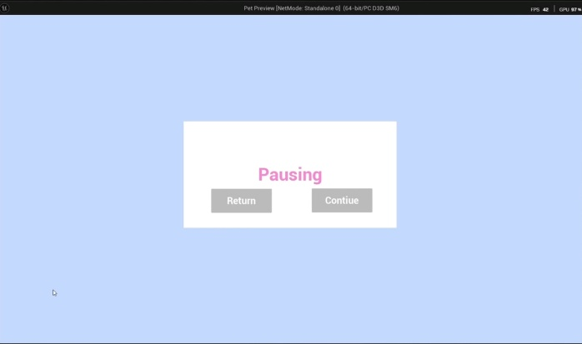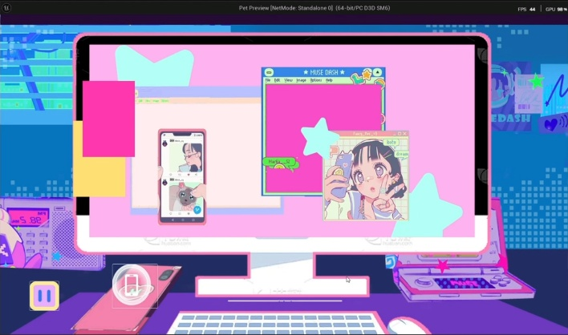
Figure6: Screenshot from paper Prototype
A key design principle behind the prototype is that the three values are initially random, but the three status values do not exist independently; they dynamically interact and influence each other. For example, feeding will reduce hunger, and when hunger reaches a certain threshold, it will increase the pet's happiness. Conversely, if the pet is not fed for a certain period and the hunger value rises to a certain value, its happiness value will decrease, while also increasing its destructiveness value. Similarly, shouting, while it can immediately suppress destructive behavior, may significantly reduce happiness, thus triggering further negative reactions. This interdependency is the core of testing, requiring players to observe, interpret, and balance multiple constantly changing values to make the best decision.
The purpose of this prototype was therefore twofold: to assess whether the player could effectively and intuitively manipulate the user interface, and to determine whether the game features worked and successfully created a sense of strategic tension. To succeed, players must explore how their interventions affect the logic of interrelated state values and manage the balance of their pet's emotions and behaviors over time.

Third Prototype ：In this phase, I introduced temporal restrictions by adding a work interface system.
In this system, players are periodically forced to stay on the work interface for a short duration. During this time, they cannot monitor the pet or perform any actions such as feeding or stopping disruptive behavior.
This creates a temporal surveillance constraint, where players lose access to both information and control for a period. As a result, they need to make decisions in advance and anticipate potential risks before losing access.
In addition, I implemented a result system that records player actions and summarizes performance at the end of each session, providing a clearer overview of player decisions.
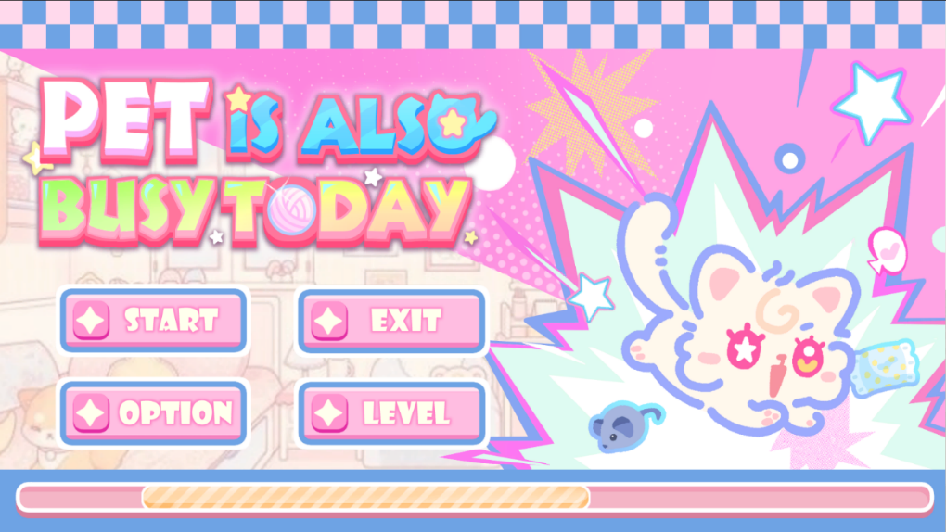

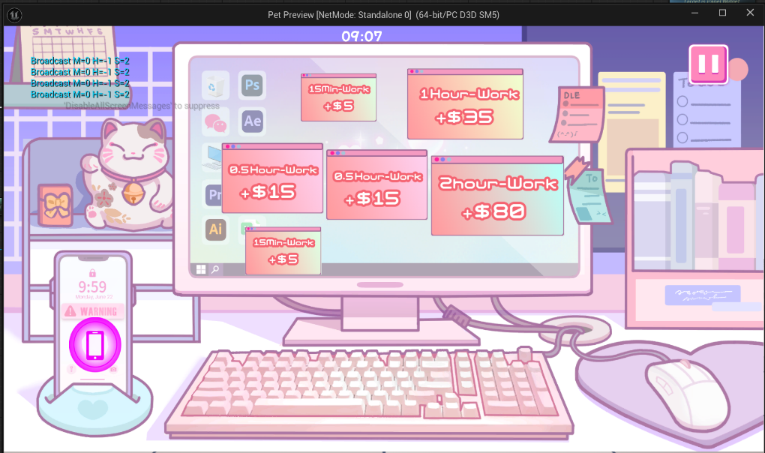

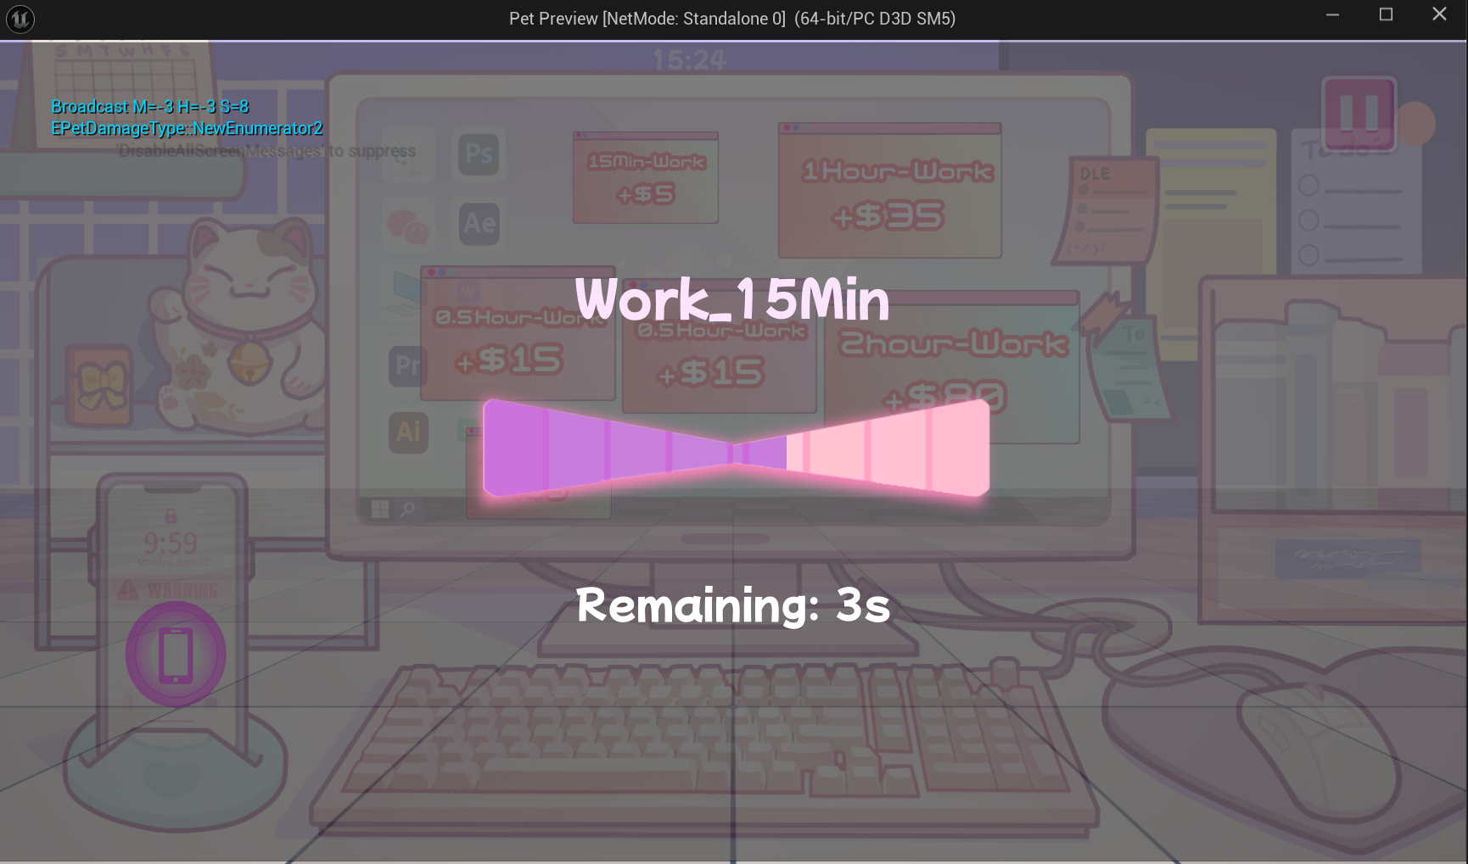
Figure7: In-game Screenshots (Main Menu, Work Menu)
Add Work Menu Restriction, players cannot back to pet menu for several times.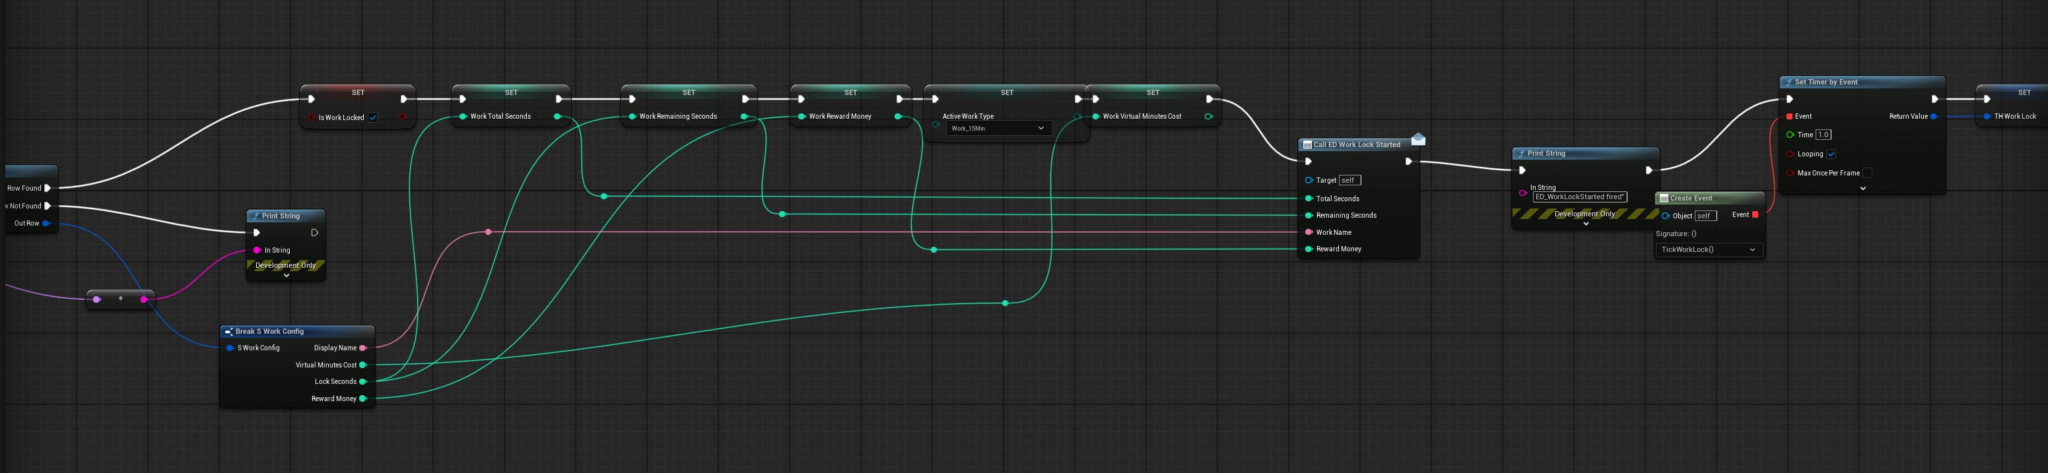
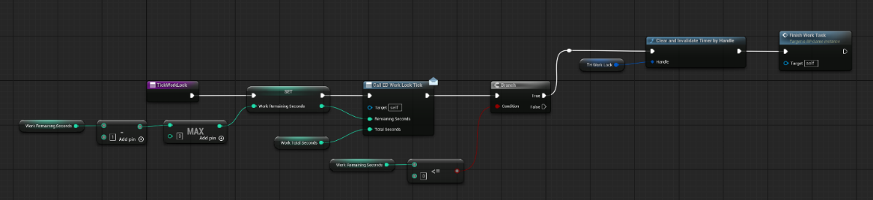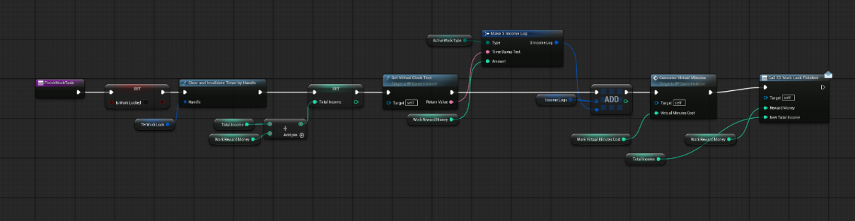
Figure8: Temporal Restriction Blueprints
Add Time Record Stamp in Result Menu for easier monitoring and prepares for final subsequent data calculations:
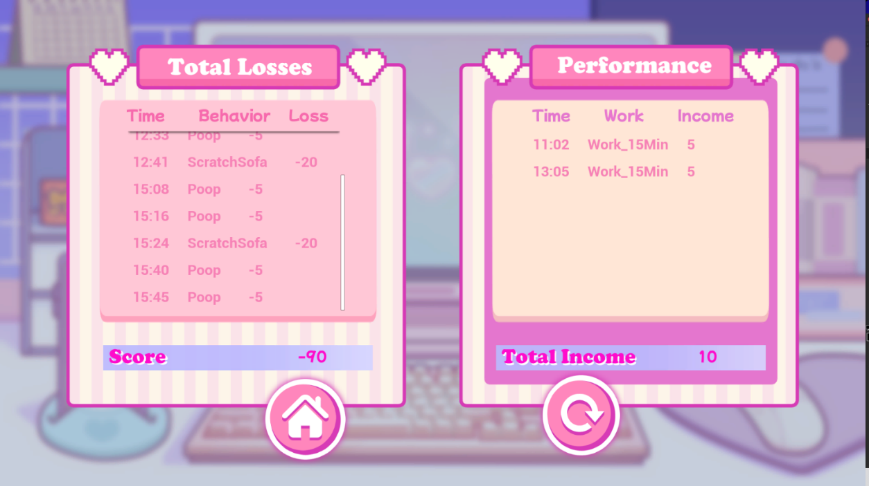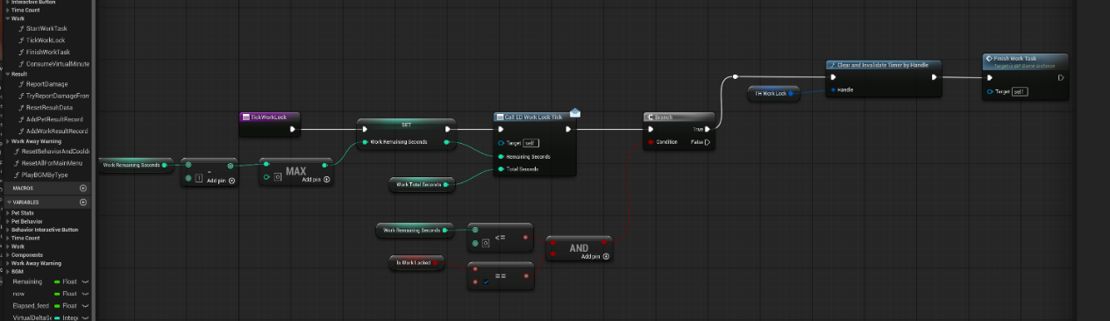
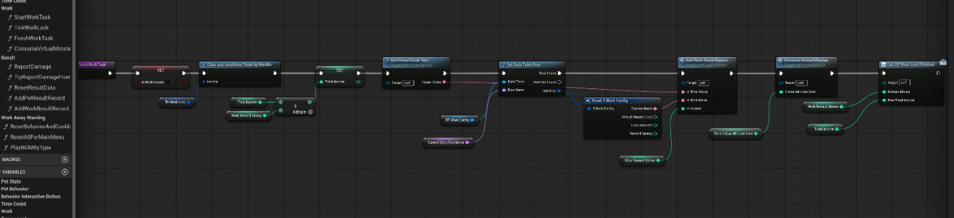
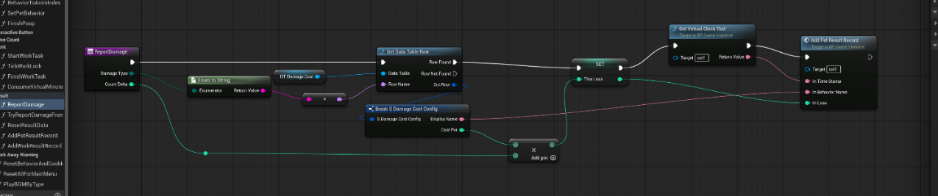
Figure9: Result Menu and Time Record Stamp Blueprint
Second Prototype：Spatial Surveillance Restriction
In this phase, I focused on implementing spatial restrictions within the monitoring system.
Players are required to actively move the camera (left, right, up, and down) to locate the pet, rather than seeing everything at once. In addition, they need to switch between the monitoring interface and the pet status panel to understand the pet’s condition.
These mechanics mean that players cannot access all information at the same time. Instead, they have to search for the pet, check its status, and piece together what is happening.
Together, these interactions create a spatial surveillance constraint, where limited visibility and fragmented information force players to actively gather information and make decisions.


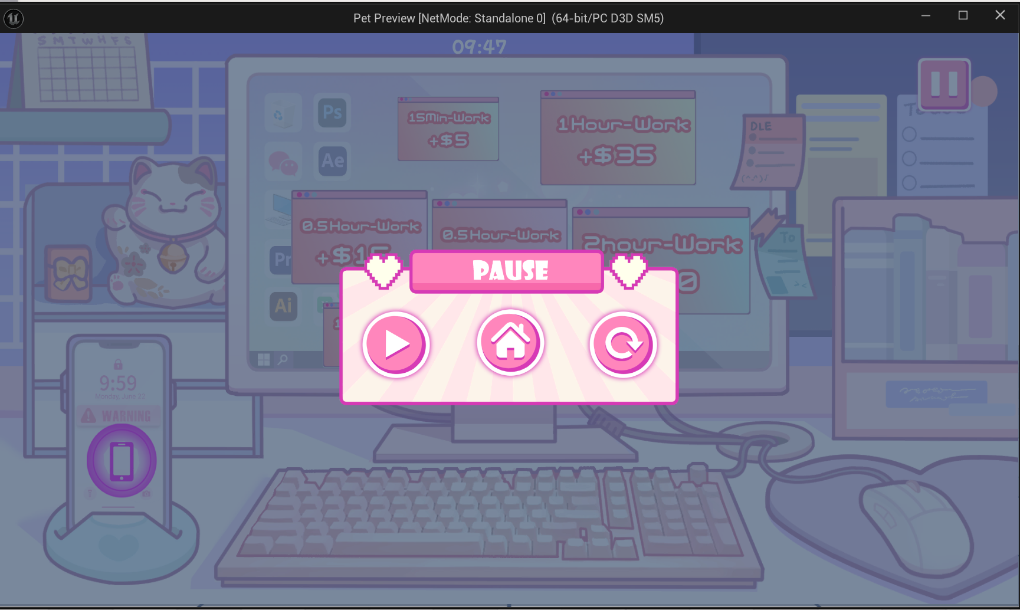
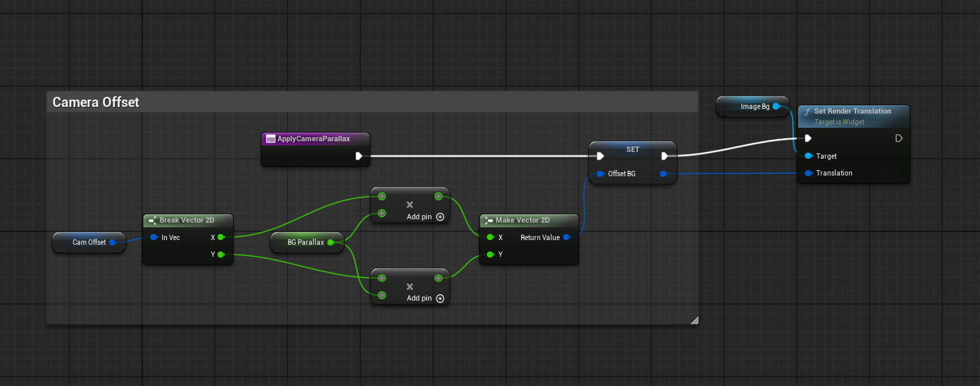
Figure10: In-game Screenshots (Camera Menu, Pause Menu)
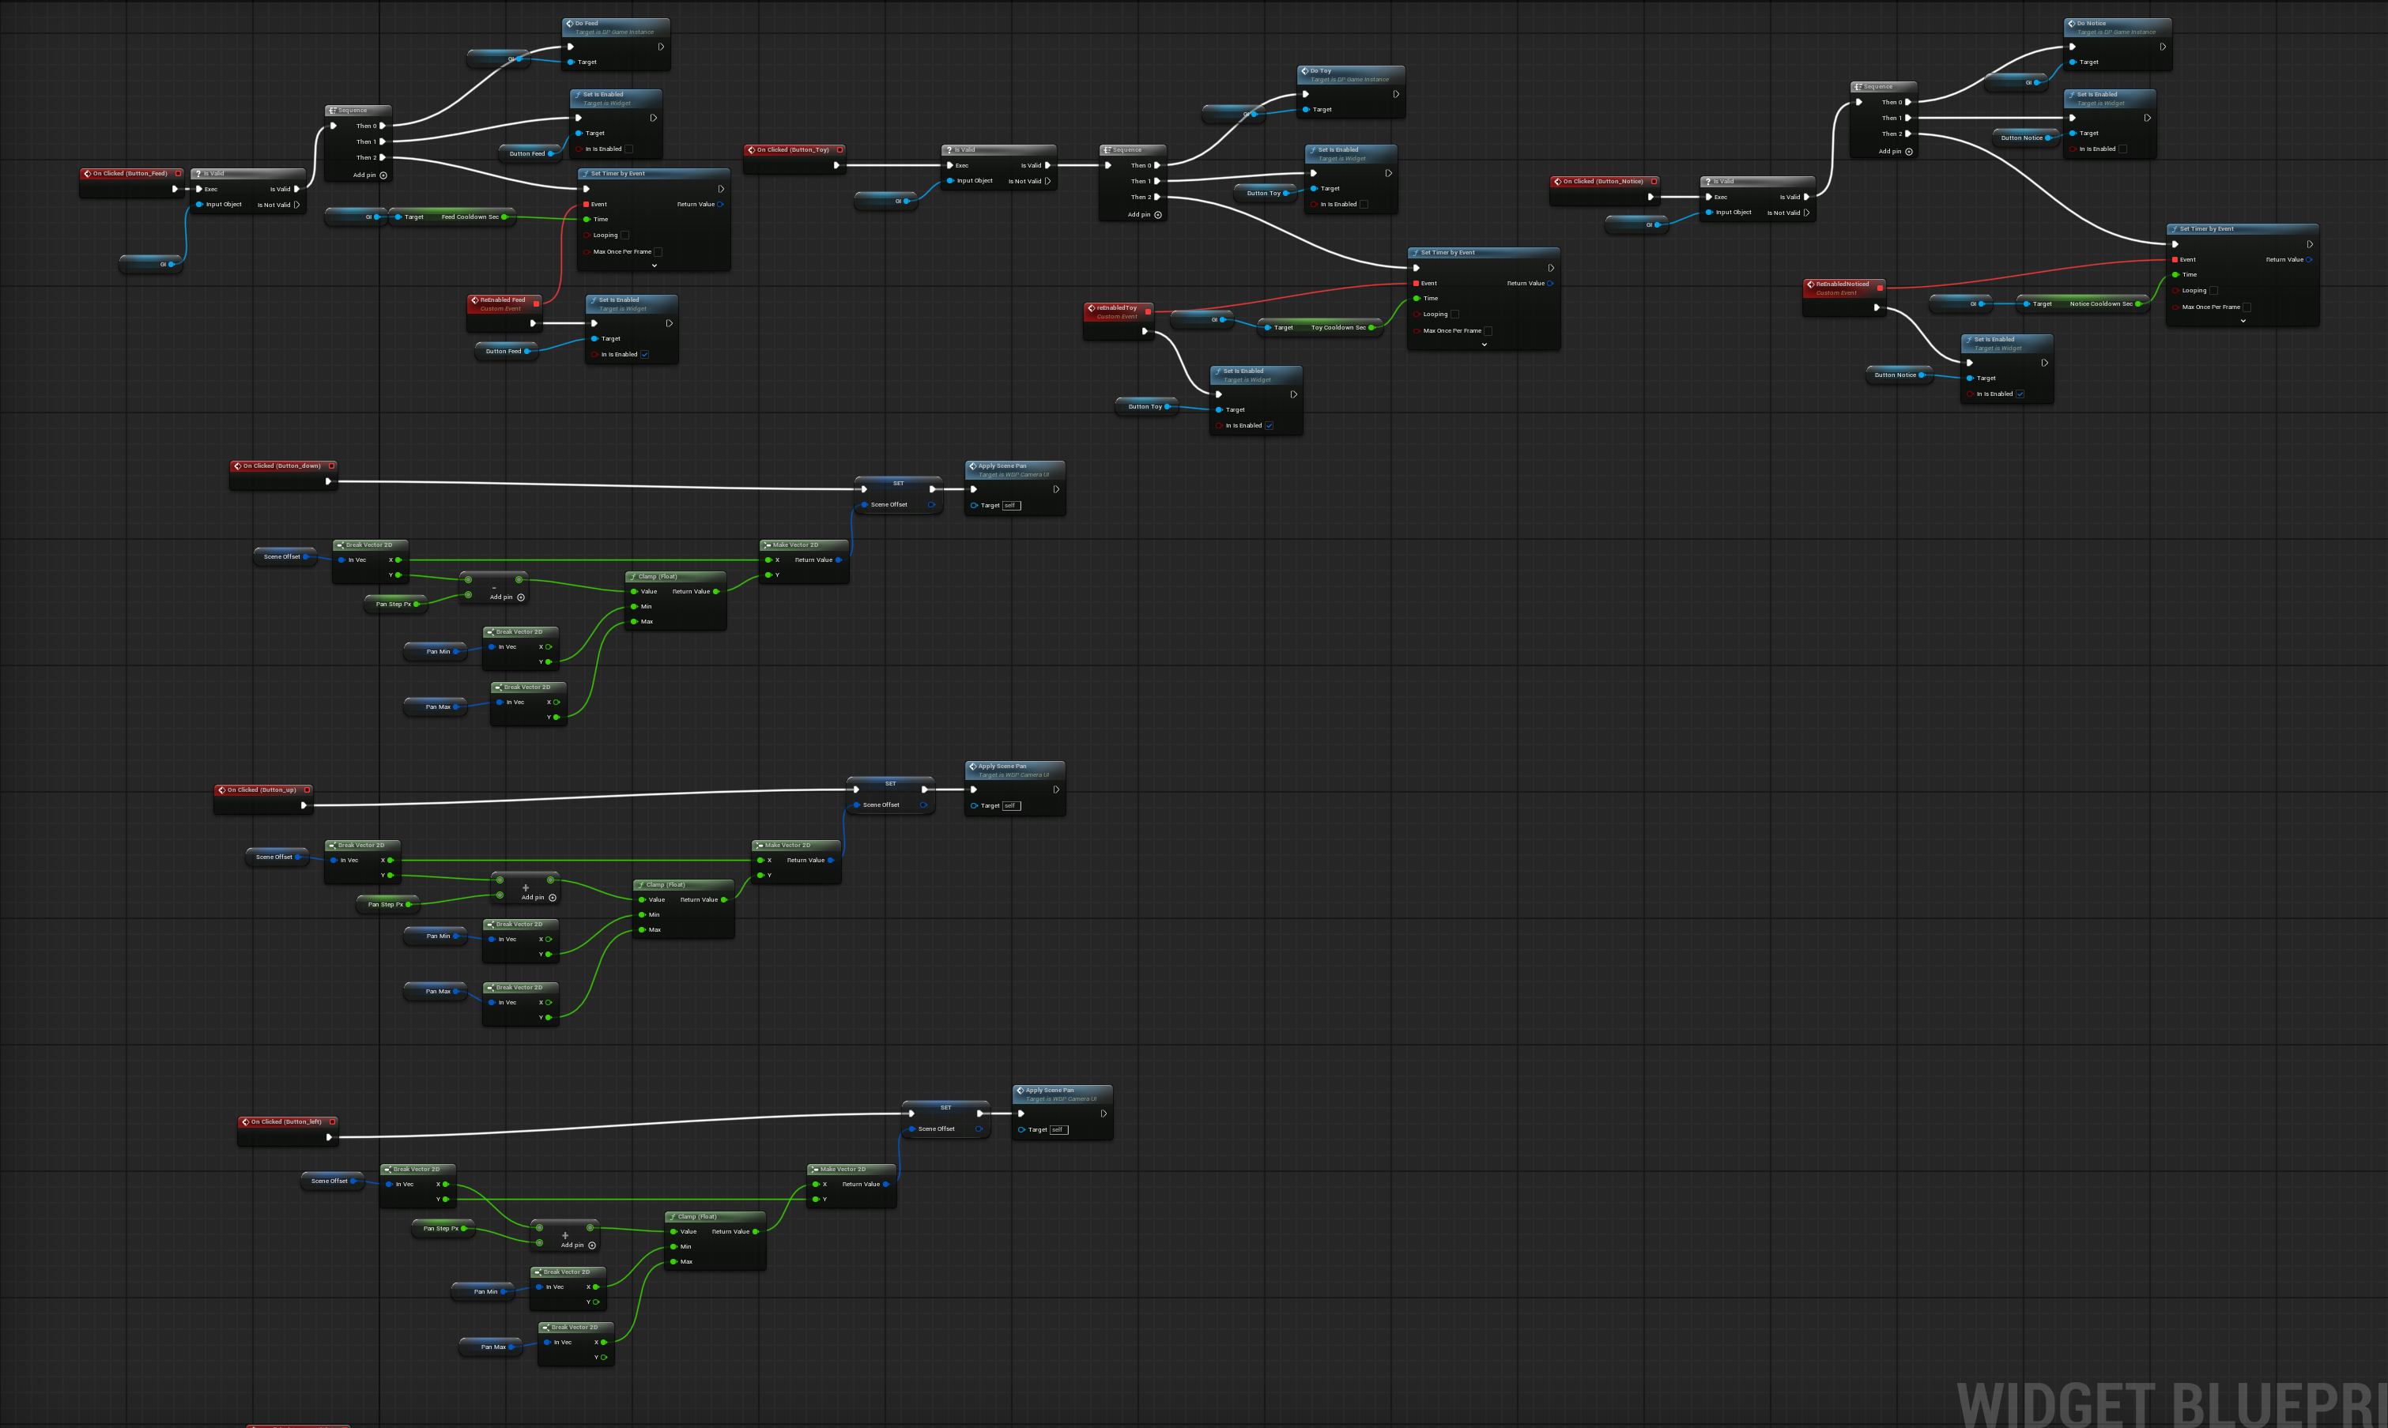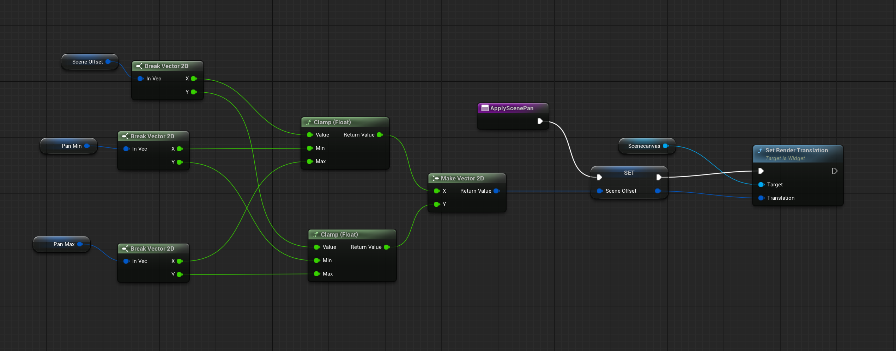
Figure11：Spatial Constraints Blueprint (Camera Move)

Validation Methodology
Research Design Overview
This study employs a structured experimental design to assess the impact of surveillance-based constraints on player behavior and perceived psychological tension within a pet simulation framework. Based on the Theory of Constraints (TOC), the study sees surveillance access as the main bottleneck in the system, which limits the information that the player can get.
Rather than eliminating constraints, this research systematically alters the degree and type of restrictions to examine how players adjust their strategies in environments characterized by limited information and control, The validation process is divided into three steps, each of which adds a new type or level of constraint.
To account for differences in playstyle and decision-making tendencies between subjects, a within-subject design (Clark, Lawrence, Astley-Jones, & Gray, 2009) is used in all phases. In-game behavioral data are collected through.
Phase 1: Temporal Surveillance Restriction
The first phase of the study examined how self-selected temporal constraints influenced player risk assessment and decision-making behavior. Twenty participants (N = 20) completed a series of gameplay trials in which they voluntarily selected different work durations in exchange for in-game currency rewards. During each work session, players temporarily lost access to pet monitoring and intervention systems.
Unlike forced interruption systems, this phase focuses on how players evaluate pet conditions before willingly entering a restricted state. The purpose of this phase is to examine whether players can balance economic reward against surveillance risk when deciding how long to leave the monitoring interface.
The primary behavioral metric in this phase is the Destructive Event Rate (DER):
$$DER=\frac{Number of Pet Destructive Events During Work }{Total Work Sessions}$$
This metric evaluates how frequently negative pet behaviors occur during periods of surveillance absence. Higher DER values suggest that players either selected overly risky work durations or failed to sufficiently evaluate the pet’s condition before entering work mode. Lower DER values indicate more effective risk assessment and temporal decision-making.
Following the experiment, participants complete Appendix B (Questionnaire 2) to report their self-perceived tension (on a 1–7 Likert scale) and their intent to anticipate pet behavior before losing access

This phase identifies temporal restriction as the principal system bottleneck, directly correlating with the Theory of Constraints by reducing the frequency of information access and necessitating proactive planning amidst uncertainty.

Phase 2: Spatial Surveillance Restriction
The second phase of the study investigated how spatial surveillance restrictions—particularly fragmented visibility and incomplete visual information—affected player tension and information-seeking behavior. Ten participants (N = 10) completed a within-subject comparison between two gameplay conditions: a Full View condition, in which the entire room remained visible at all times, and a Restricted View condition, which required players to actively pan the camera in order to locate the pet.
To evaluate the effect of spatial restriction on perceived tension, a within-subject experiment was conducted.
Ten participants played two versions of the game:
- Restricted view condition: players could only see part of the room and had to move the camera to locate the pet.
- Full view condition: players could see the entire room at all times.
After playing both versions, participants complete Appendix C (Questionnaire 3) to assess whether the uncertainty of "what might happen outside the view" significantly increases psychological pressure and the fear of missing critical events.
This design allows direct comparison of perceived tension under different levels of visual access, while controlling for individual differences in player behavior.
Phase 3: Integrated Constraint Validation
The third phase of the study investigated how combined temporal and spatial surveillance restrictions influenced player tension, uncertainty, and decision-making behavior within pet simulation gameplay. Unlike the previous phases, which examined temporal and spatial bottlenecks independently, this phase evaluated the effect of applying both constraints simultaneously within a single gameplay condition.
To evaluate the effect of integrated constraints on perceived psychological pressure, a large-scale player testing session was conducted with 40 participants (N = 40).
During gameplay, participants experienced a combined surveillance system that included:
- restricted camera visibility requiring active searching,
- temporary loss of monitoring access during work sessions,
- and uncertainty regarding off-screen pet behavior while intervention was unavailable.
Several questionnaire items specifically addressed whether the combined use of temporal and spatial bottlenecks generated stronger psychological pressure than a typical pet simulation experience. Additional items focused on whether players felt overwhelmed by the need to simultaneously search, monitor, and prioritize information under restricted conditions.
This validation phase investigates whether layered surveillance constraints increase cognitive workload beyond simple reactive monitoring and encourage more deliberate prioritization, predictive attention, and adaptive strategic behavior under uncertainty.
Survey Results and Analysis：
First and Second Demo feedback：
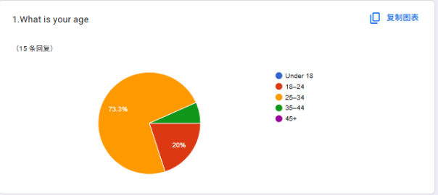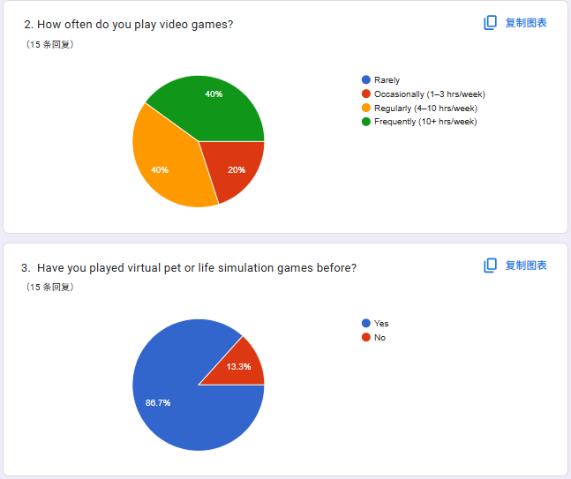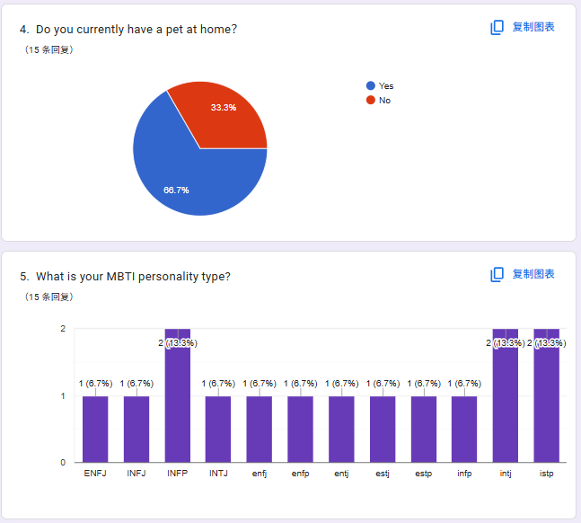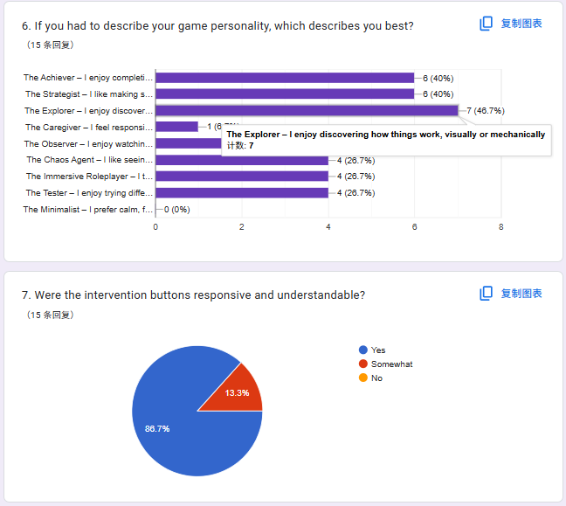
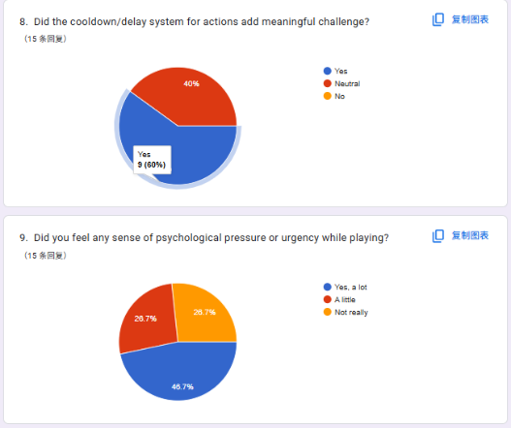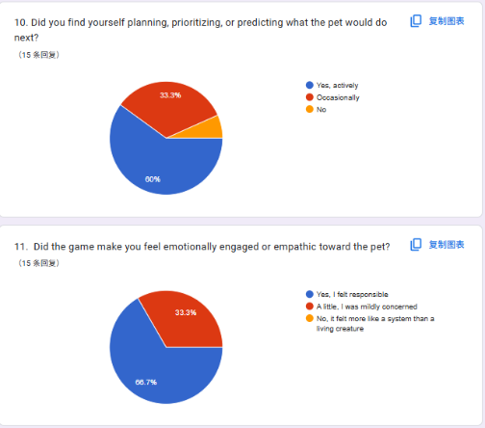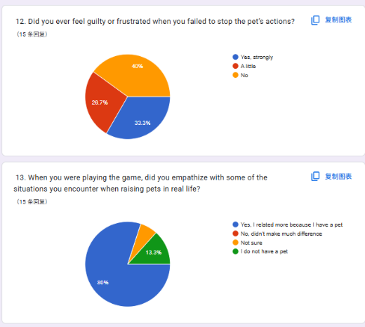
Figure12: Results of Prototype testing feedback questionnaire
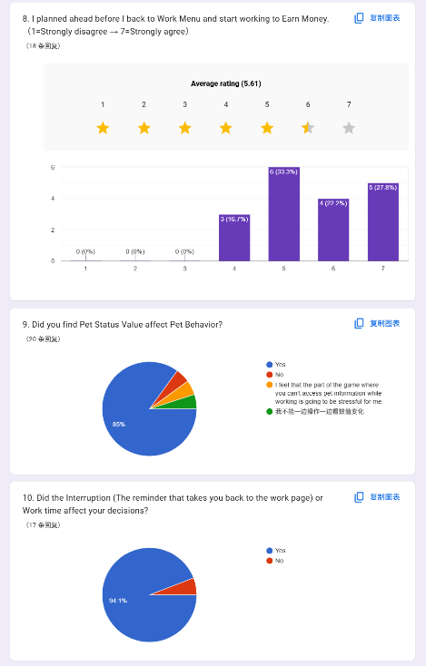
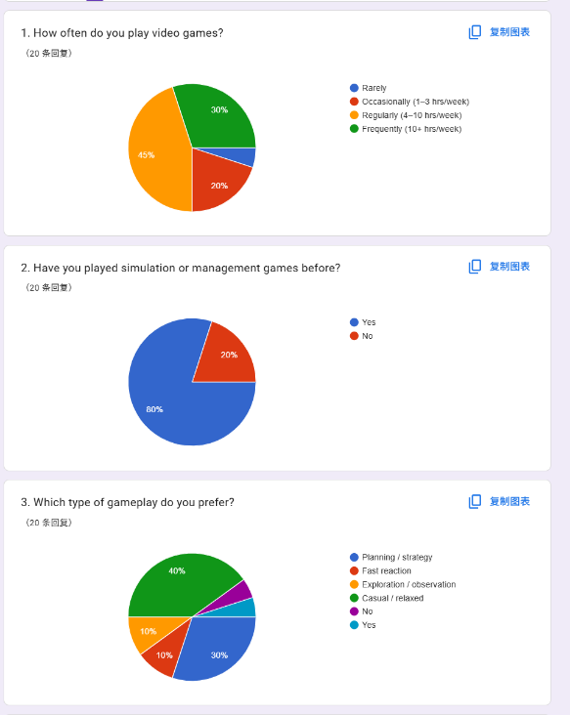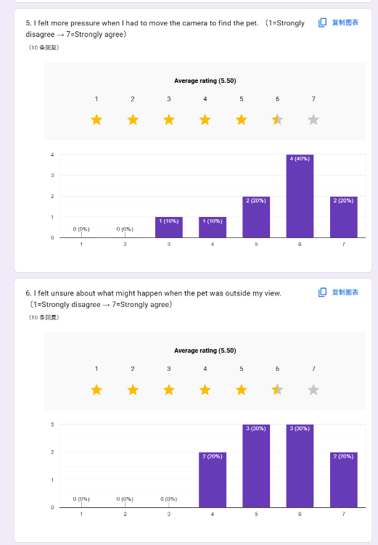
Figure13: Results of Temporal Constraints Test
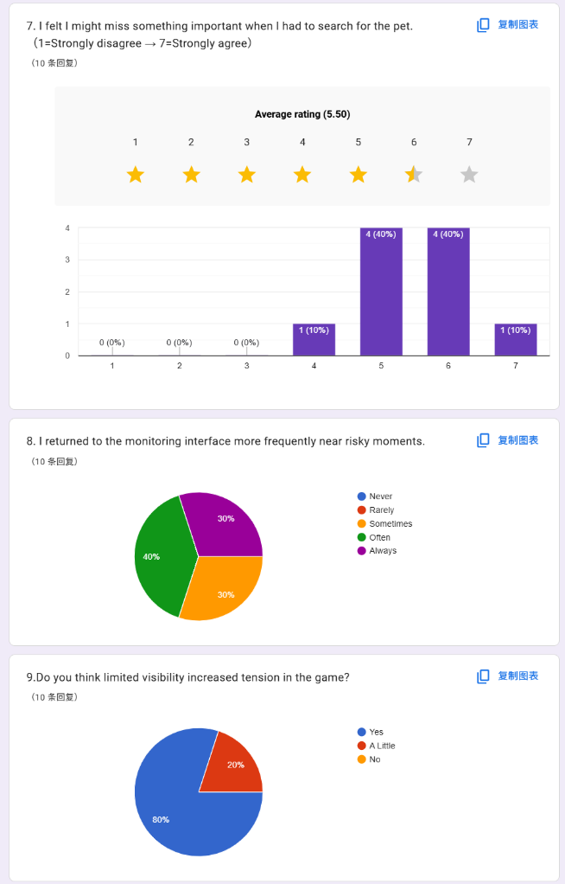
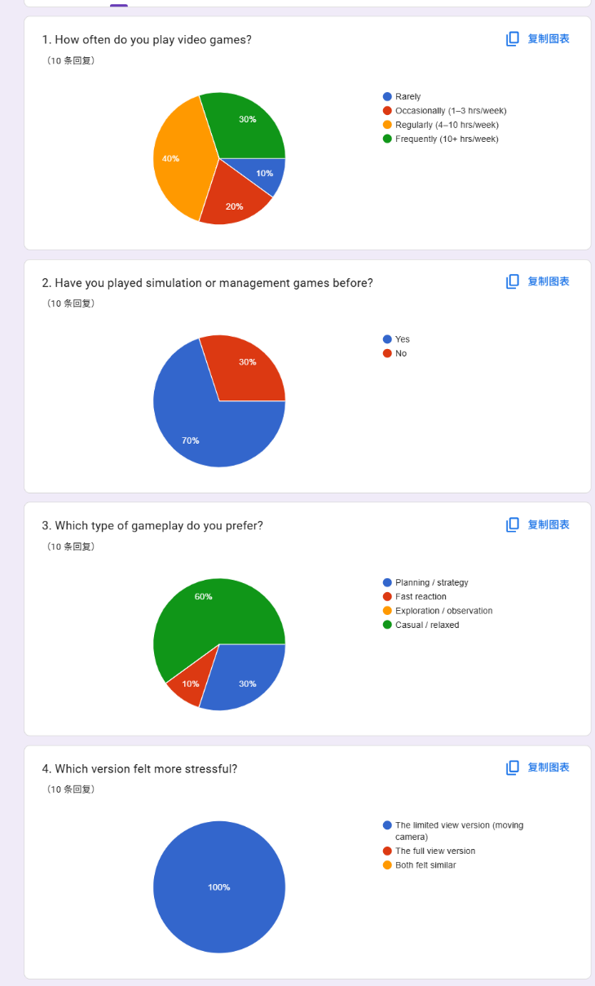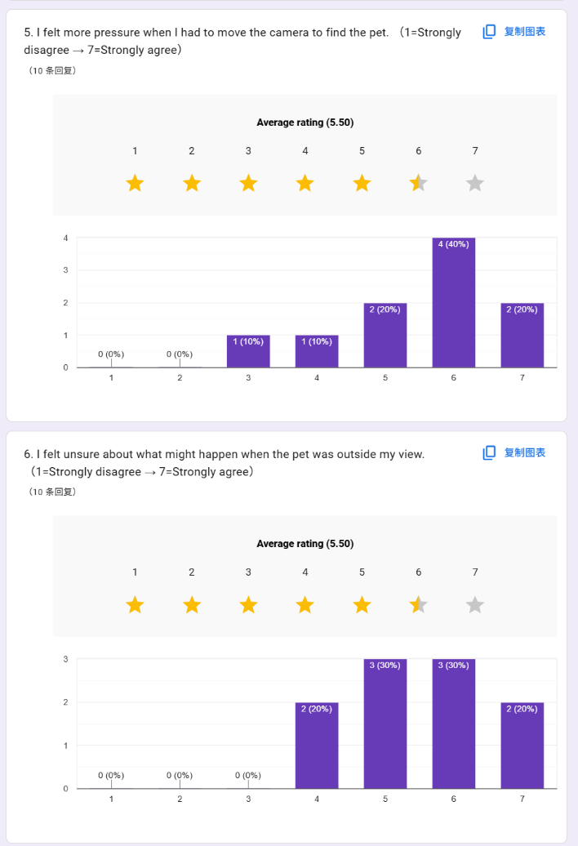
Figure14: Results of Spatial Constraint Test

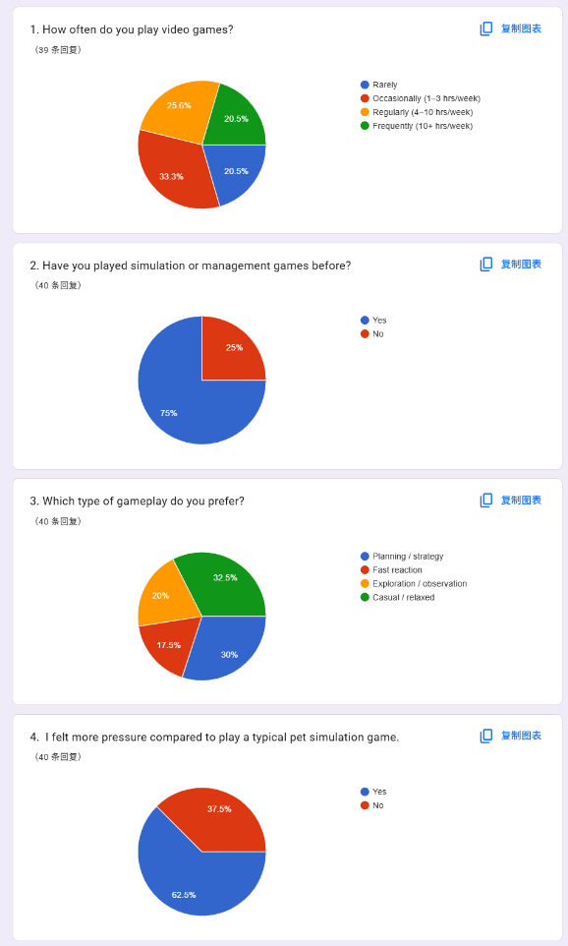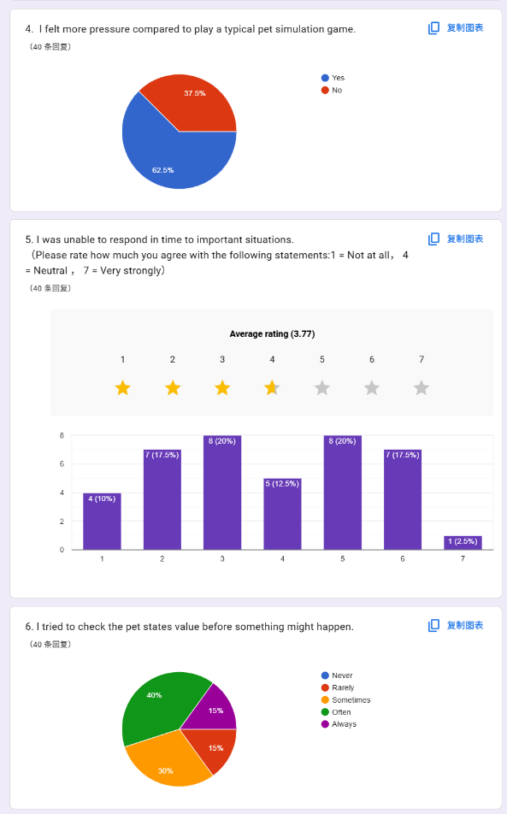
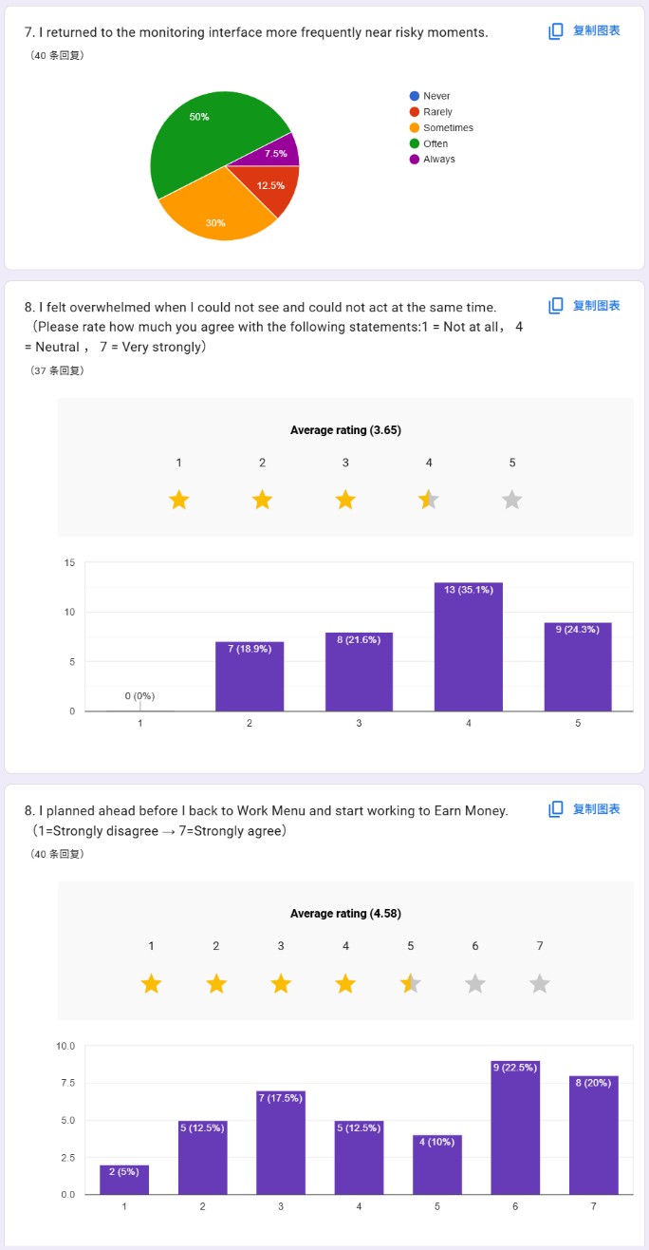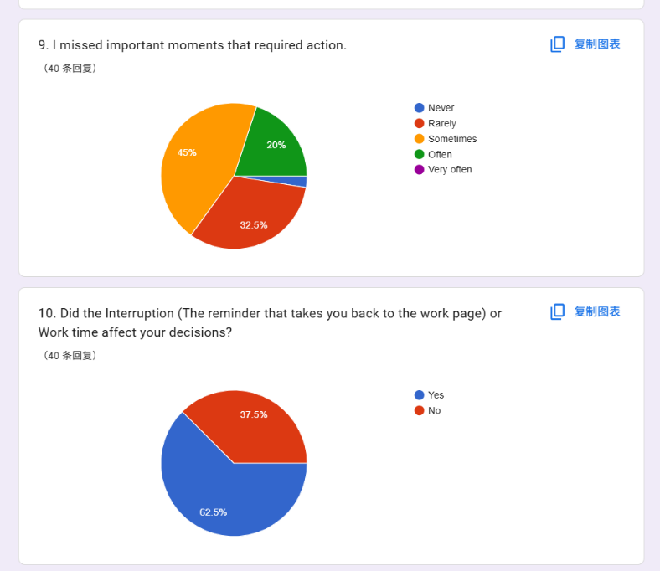
Figure14: Results of Final Integrated Constraint Test

Test 2 Feedback Interview
The second prototype (Version 2 Demo), five people took part in a one-on-one test round. The goal of this phase was to watch how players interacted with each other, how well they understood the system, and how much fun they had playing the game with the new design.
All players said they felt a noticeable amount of psychological tension while playing, especially in the middle of the game when they couldn't keep an eye on their pet all the time. All the participants felt this tension all the time.
Participant 2-1 noted that although the game created a sense of tension, the intensity was limited due to a lack of clear consequences: “I can feel some tension when I can't watch the pet, but it’s not very strong because nothing really happens if I don’t react immediately. There’s no clear punishment.”
Participant 2-2 expressed confusion about the consequences of pet behavior and the lack of feedback in the work system: “I didn’t realize that the pet making trouble would cause a loss. And when I was forced back to the work screen, there was no penalty either, so I just went back to take care of the pet again.”
Participant 2-3 commented on the lack of clarity in system priorities: “I wasn’t sure which one I should focus on more, the pet or the work. It felt like both were important, but the game didn’t really tell me what would happen if I ignored one.”
Participant 2-4 highlighted the role of immediate visual feedback in shaping urgency: “I kept watching the pet because I could see what it was doing. And if I didn’t pay attention, it would quickly go into a warning state and start doing something bad. That made it feel urgent, but I was mostly reacting to it instead of planning ahead.”
Participant 2-5 also noted that the sense of urgency was primarily driven by visible warning cues: “It still felt urgent, because if I didn’t watch the pet, it would quickly go into a warning state and start doing something bad. So I kept reacting to it.”

Results:
Phase 1: Results of Self-Selected Temporal Constraint Test
The primary behavioral metric used in this phase was the Destructive Event Rate (DER), which measures the frequency of destructive pet behaviors occurring while the player was absent from the monitoring system.
Table2: Destructive Event Rate (DER) Across Work Durations
Work Duration (s) | DER
5 seconds | 0.12
10 seconds | 0.19
15 seconds | 0.26
20 seconds | 0.34
The analysis indicates that longer work sessions produced a steady increase in destructive events, although the increase remained incremental rather than extreme. Even under the 20-second condition, participants attempted to reduce risk by checking pet status values—particularly Mischief and Hunger—before entering work mode. However, the longer surveillance absence created greater informational uncertainty, increasing the likelihood of destructive pet behavior that could no longer be prevented in time.
Qualitative Feedback: Questionnaire 2 Analysis Following the sessions, participants provided feedback via Questionnaire 2 (Appendix B) using a 7-point Likert scale. The qualitative results correlate with the behavioral trends observed:
- Perceived Tension (Mean=6.1, Standard Deviation=0.8): Participants reported consistent psychological tension when monitoring was blocked, particularly during the 15s and 20s durations.
- Pre-work Evaluation (Mean =5.8, Standard Deviation =1.2): Most players agreed with the statement "I tried to check the pet state before something might happen," suggesting a conscious attempt at strategic foresight.
- Pressure of Inaction (Mean =5.9): The inability to intervene for 20 seconds created the highest reported pressure, validating the "temporal bottleneck" as a significant driver of cognitive urgency.

Phase 2: Results of Spatial Surveillance Restriction Test
Consistent with the study hypothesis, most participants perceived the Restricted View condition as substantially more stressful than the Full View condition. Specifically, 90% of participants identified the limited-visibility version as producing higher psychological pressure.
From the perspective of the Theory of Constraints (TOC), the restricted camera system functioned as a spatial bottleneck by limiting informational throughput. Because players could no longer access the entire environment simultaneously, they were required to continuously search for missing information while managing uncertainty about off-screen events.
Quantitative3 Results Analysis:
Table3: Perceived Tension and Pressure Metrics Under Spatial Restriction
Survey Item (Questionnaire 3) | Mean (M) | Standard Deviation (SD)
Pressure caused by moving the camera to locate the pet | 5.8 | 0.92
Uncertainty regarding pet behavior outside the visible area | 6.4 | 0.70
Fear of missing important events while searching | 6.1 | 1.05
Overall increase in tension caused by limited visibility | 6.5 | 0.53
Among all questionnaire items, uncertainty regarding off-screen pet behavior produced the highest mean score (M = 6.4). This finding suggests that restricted visibility significantly increased informational uncertainty during gameplay.
Rather than functioning as a passive observation system, the surveillance mechanic became an active search process in which players continuously attempted to recover missing information. The scarcity of visual access therefore operated as a direct source of psychological tension.

Phase3: Result of Final Integrated Constraint Test
The findings from Phase 3 suggest that the combined use of temporal and spatial surveillance restrictions significantly increased psychological tension, cognitive demand, and strategic pressure throughout gameplay.
Participant background data indicated that 75% of the sample had prior experience with simulation or management games. Although gaming frequency varied among participants, only 17.5% identified fast-reaction gameplay as their preferred genre, while 30% expressed a preference for planning- or strategy-oriented experiences. This distribution suggests that the prototype primarily engaged players who value decision-making and management processes over purely reflex-based interaction.
Participants consistently described the integrated constraint condition as more stressful than a conventional pet simulation experience. Overall, 62.5% reported that the combined restrictions generated noticeably higher pressure than typical genre expectations. Participants also reported moderate difficulty responding to important situations in time, with a mean score of M = 3.77/7. These results indicate that limiting surveillance access reduced players’ ability to rely on immediate reactive behavior, despite the absence of mechanically intensive gameplay demands.
The questionnaire responses further revealed evidence of anticipatory monitoring behavior. Approximately 55% of participants stated that they “Often” or “Always” checked pet status values before important events occurred. In addition, 57.5% reported returning to the monitoring interface more frequently during high-risk moments. Together, these findings suggest that players began treating monitoring access as a limited resource, directing their attention toward moments perceived as strategically important.
At the same time, the combined restriction system produced a considerable sense of cognitive overload. The item measuring feelings of helplessness when players were unable to both monitor and intervene yielded an average score of M = 3.65/5, with 59.4% of participants selecting scores within the upper range (4–5). This pattern indicates that the layered surveillance constraints successfully generated sustained uncertainty and informational pressure.
Participants also demonstrated attempts at proactive preparation before entering work mode. The statement measuring advance planning prior to work interruptions produced a mean score of M = 4.58/7, suggesting that many participants attempted to stabilize the system before voluntarily losing access to surveillance tools. Nevertheless, despite these planning efforts, 65% reported that they “Sometimes” or “Often” missed moments requiring intervention. This finding implies that the integrated constraints created enough systemic pressure to challenge player control even when anticipatory behavior was present.
Finally, 62.5% of participants agreed that work interruption reminders and work duration selection directly influenced their gameplay decisions. Overall, the results support the central premise of this study: intentional mechanical constraints not only generate psychological tension, but also reshape how players allocate attention, prioritize information, and engage in strategic decision-making under uncertainty.

Conclusion
This thesis examined how intentional mechanical constraints can be used to introduce strategic tension into pet simulation gameplay. Rather than treating pet simulation as a purely relaxing or passive care loop, the project explored how limited access to information, restricted monitoring, and delayed intervention can reshape the way players observe, plan, and make decisions.
Through the development and testing of a playable prototype, the research found that deliberately designed mechanical constraints can meaningfully reshape the player’s relationship to care. When players could not always see, act, or intervene immediately, pet care became less about constant reaction and more about risk assessment, anticipation, and prioritization. The game’s temporal and spatial restrictions encouraged players to think about when to monitor, when to work, when to intervene, and how much uncertainty they were willing to accept.
At the same time, the project also showed that constraint-based design depends heavily on clarity. Tension was strongest when players understood what was at risk, how pet states affected behavior, and why their choices mattered. When feedback, UI communication, or system consequences were unclear, some players experienced confusion rather than deliberate strategy. This distinction became important to the research: effective constraint design does not simply remove player control; it must communicate enough information for players to make meaningful decisions under pressure.
Overall, this study suggests that pet simulation games can support deeper strategic engagement when constraints are designed as part of the core system rather than added as punishment. By framing surveillance access as a limited resource, the project demonstrates a possible design direction for transforming virtual pet care into a more active, tension-driven, and decision-based experience.

Limitations and Future Directions
Limitation
Several limitations should be acknowledged regarding both the prototype and the validation process. First, the project was developed as a complete playable game experience rather than a tightly controlled experimental system. Multiple mechanics—including surveillance, work management, pet states, intervention systems, and economic progression—operated simultaneously during testing. As a result, player behavior was influenced by the interaction of several overlapping systems rather than by a single isolated variable.
Another limitation concerns the clarity and readability of the gameplay systems. Participant feedback revealed that some players required considerable time to understand the relationship between pet states, work systems, surveillance restrictions, and destructive behaviors. In many cases, players were not only learning how to identify pet conditions, but also trying to understand how different systems affected one another, such as how work duration influenced risk or which pet states were associated with negative outcomes.
Because the gameplay sessions used during testing were relatively short, some participants had not fully understood the overall system logic before the session ended. Combined with limitations in onboarding, UI readability, and feedback communication, this created noticeable differences in how players interpreted and responded to the restriction systems. While many participants gradually adapted and began engaging in predictive monitoring and advance planning, others became overwhelmed by time pressure, limited visibility, and incomplete information. Some players failed to fully recognize the relationship between pet values and destructive behaviors, leading to confusion and reactive play behavior. However, this uncertainty itself also contributed to the tension generated by the system.
Finally, portions of the analysis relied on self-reported questionnaire data rather than fully automated gameplay telemetry. Although timestamp systems and event logs were implemented to support observation, measurements related to anticipation, strategic intention, and cognitive pressure still depended partially on participant interpretation and subjective reporting.
Future Directions
Future research may further investigate how different forms of intentional restriction—such as temporal limitation, spatial restriction, visual limitation, and other constrained interaction systems—produce different levels of emotional pressure, strategic demand, and cognitive workload across different player groups. Different forms of restriction may influence players in different ways: some may increase stress through uncertainty and delayed response, while others may require players to spend more time monitoring, predicting, or allocating attention under limited information conditions. Further study of these relationships may help establish more systematic approaches to emotional pacing and tension balancing in game design. By identifying how different restriction systems affect player emotion, strategic behavior, attention distribution, and psychological pressure, future research may help designers better structure gameplay flow and emotional curves throughout interactive experiences.
In addition, this research direction may provide level designers and gameplay designers with more measurable reference ranges for balancing player tension under different gameplay conditions. For example, future studies may examine what levels of emotional pressure are generated by specific forms of spatial restriction, visual limitation, or temporal interruption for different player types. These findings could potentially support the creation of more controlled and intentional emotional progression systems within games.
Beyond game design, this research direction may also contribute to broader studies related to emotional attachment and human–pet relationships within virtual environments. Future studies may investigate how simulated caregiving systems influence player empathy, emotional responsibility, and attachment toward virtual companions. In addition, the relationship between pet care systems, emotional stress, and player behavior may provide opportunities for interdisciplinary research connected to psychology, emotional well-being, and studies of companion-animal relationships within domestic environments.
Finally, future studies may benefit from larger participant samples, longer testing durations, and more detailed gameplay telemetry in order to better understand how players gradually learn, interpret, and adapt to constrained interactive systems over time.
Development Team:
This prototype is being developed primarily by Zhiyun Yu, who is responsible for all gameplay systems, UI logic, interaction design, concept design and scripting in Unreal Engine 5.
Visual support (such as Pet design, environment design and character design) will be provided by Wanzhen Mei, a collaborator focused on post-production art assets. All core development and system logic are handled independently by the primary researcher.

Appendix
Questionnaire:
Questionnaire 1: Post-Play Test
- What is your age?
- How often do you play video games?
- Have you played virtual pet or life simulation games before?
- Do you currently have a pet at home?
- What is your MBTI personality type?
- If you had to describe your game personality, which describes you best?
- Were the intervention buttons responsive and understandable?
- Did the cooldown/delay system for actions add meaningful challenge?
- Did you feel any sense of psychological pressure or urgency while playing?
- Did you find yourself planning, prioritizing, or predicting what the pet would do next?
- Did the game make you feel emotionally engaged or empathic toward the pet?
- Did you ever feel guilty or frustrated when you failed to stop the pet’s actions?
- When playing, did you empathize with real-life pet situations?
- What did you find most enjoyable or unique about the game?
- What would you improve or adjust?
Questionnaire 2: Temporal Constraint Test
- How often do you play video games?
- Have you played simulation or management games before?
- Which type of gameplay do you prefer?
- I felt tense when I could not monitor the pet.
- I felt pressure knowing I could not act for a period of time.
- I tried to check the pet state before something might happen.
- I returned to the monitoring interface more frequently near risky moments.
- I planned ahead before I lost access to the pet.
- Did you find that pet state values affect pet behavior?
- Did the interruption (being forced back to the work screen) affect your decisions?
Questionnaire 3: Spatial Constraint Test
- How often do you play video games?
- Have you played simulation or management games before?
- Which type of gameplay do you prefer?
- Which version felt more stressful?
- I felt more pressure when I had to move the camera to find the pet.
- I felt unsure about what might happen when the pet was outside my view.
- I felt I might miss something important when I had to search for the pet.
- I returned to the monitoring interface more frequently near risky moments.
- Do you think limited visibility increased tension in the game?
Questionnaire 4: Final Complex Constraint Test
- How often do you play video games?
- Have you played simulation or management games before?
- Which type of gameplay do you prefer?
- I felt more pressure compared to play a typical pet simulation game.
- I was unable to respond in time to important situations.
- I tried to check the pet states value before something might happen.
- I returned to the monitoring interface more frequently near risky moments.
- I felt overwhelmed when I could not see and could not act at the same time.
- I planned ahead before I back to Work Menu and start working to Earn Money.
- I missed important moments that required action.
- Did the Interruption (The reminder that takes you back to the work page) or Work time affect your decisions?

Figures:
Figure 1. From “MDA: A Formal Approach to Game Design and Game Research” by R. Hunicke, M. LeBlanc, and R. Zubek, 2004, “Proceedings of the AAAI Workshop on Challenges in Game AI”. Copyright 2004 by the authors.
Figure 2. Core loop
Figure 3. UI Sketch
Figure4: Narrative Comic Storyboard (Introduce the background)
Figure5: Visual style confirms
Figure6: Screenshot from paper Prototype
Figure7: In-game Screenshots (Main Menu, Work Menu)
Figure8: Temporal Restriction Blueprints
Figure9: Result Menu and Time Record Stamp Blueprint
Figure10: In-game Screenshots (Camera Menu, Pause Menu)
Figure11：Spatial Constraints Blueprint (Camera Move)
Figure12: Results of Prototype testing feedback questionnaire
Figure13: Results of Temporal Constraints Test
Figure14: Results of Spatial Constraint Test

Tables:
Table1: A systematic analysis of 20 commercially successful mobile pet simulators
Table2: Destructive Event Rate (DER) Across Work Durations
Table3: Perceived Tension and Pressure Metrics Under Spatial Restriction

Bibliography
Science of Business. (n.d.). Theory of Constraints games.
https://www.scienceofbusiness.com/theory-of-constraints-games/
Atkinson, F., & Pruszko, L. (2025). Player agency under constraint: A pilot study on the forced-choice effect in narrative difficulty design. In Proceedings of the 2025 Conference on Creativity and Cognition (pp. 404–408). Association for Computing Machinery. https://doi.org/10.1145/XXXXXXX
Costikyan, G. (2013). Uncertainty in games. MIT Press.
Hunicke, R., LeBlanc, M., & Zubek, R. (2004). MDA: A formal approach to game design and game research. Retrieved from http://users.cs.northwestern.edu/~hunicke/MDA.pdf
Research and Markets. (2025). Virtual pet simulator apps market forecast to 2030. https://www.researchandmarkets.com/
Sensor Tower. (2024). Q1 performance of top virtual pet apps on Android and iOS in the US. https://www.sensortower.com/
Spiliopoulos, L., Ortmann, A., & Zhang, L. (2018). Complexity, attention, and choice in games under time constraints: A process analysis. Journal of Experimental Psychology: Learning, Memory, and Cognition, 44(10), 1609–1640. https://doi.org/10.1037/xlm0000535
Pisklak, J. M., Yong, J. J. H., & Spetch, M. L. (2019). The near-miss effect in slot machines: A review and experimental analysis over half a century later. Journal of Gambling Studies. https://doi.org/10.1007/s10899-019-09891-8
Acknowledgments
This project was developed by Yu Zhiyun. All game logic, UI interactions, and prototype scripts were implemented independently using Unreal Engine 5.5.

I would like to thank:
All volunteer testers who provided valuable feedback during the initial prototyping phase.
Mei Wanzhen, who contributed visual assets to the game.
Figma: Core Loop, Timeline Gantt Chart
ChatGPT: Assist in Translation, Grammar Checking
Google Form: Testing Feedback
Photoshop: Concept Design, Before-Game Comic, Pet and Character
Adobe Illustrator: UI
After Effects: Animation
Maya, Substance 3D Painter: Environment Model

